 | 

Work Package 3: Theoretical and practical teaching materials development for transport in Cameroon and the Democratic Republic of Congo

T3.5 Logistic management
Supply management and logistics - Tutorial



MODELING OF LOGISTICS PROCESSES
ACTIVITY #8

Basic conveyor system with decision points

List of authors:
Gdansk University of Technology
Daniel Kaszubowski, Justyna Staszak-Winkler, Wojciech Kustra

Contents:

1 Objective and new skills 3
2 Assumptions and input data 3
3 Object parameters and flow logic 4
3.1 Conveyor system 4
3.2 Flow element 5
3.3 Decision point controlling the flow direction 5
3.4 Decision points before service stations 5
3.5 Processing stations 6
3.6 Decision points releasing zones 7

Objective and new skills
The task aims to master the basics of using decision points on conveyors to control the flow of elements using access zones.
New skills
Decision point configuration
Creating, occupying and releasing zones
Saving data on the use of zones

Assumptions and input data
The model represents the transfer of flow elements through a conveyor system and takes into account the following assumptions:
- The source generates three different types of products according to an exponential distribution with a scale parameter value of 10 seconds.
- The products are automatically transferred to a simple conveyor, at the end of which there are three chutes for each of the processed products. The decision on which chute to use is made at the decision point before the first chute.
- At each of the chutes, the product is processed, the duration of which depends on the product's mass - the weight of a single element oscillates between 1 and 15 kg. It was assumed that 1.5 seconds were spent per 1 kg.
- Only one product can be in the weighing zone at a time, limited by decision points.
- At weighing stations, information is updated about the number of weighed products, total weighing time and the degree of use of the stations. Labels written on objects are updated dynamically.
- A record is kept of the weighing time of individual items.
- The load of weighing stations and their throughput are analysed.

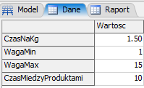
The input data is located in the global Data table (Fig. 1).

Fig. 1 Input data

The target layout of the model is shown in Fig. 2.
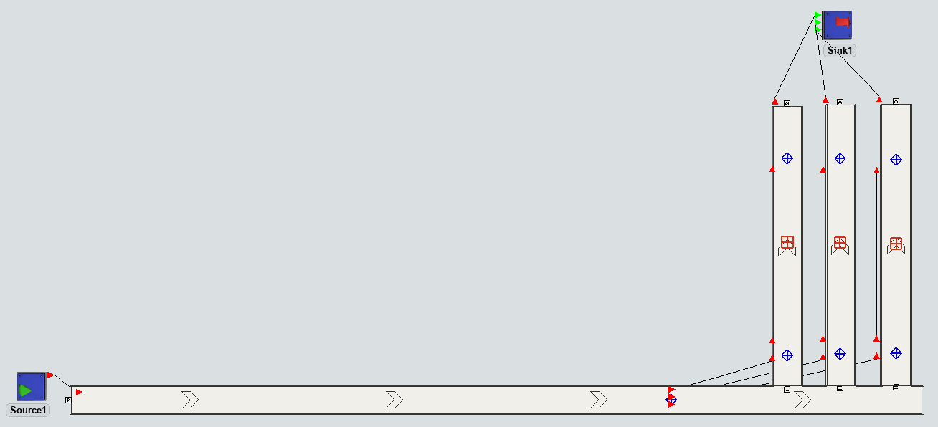
Fig. 2. Target model layout

Object parameters and flow logic

Conveyor system
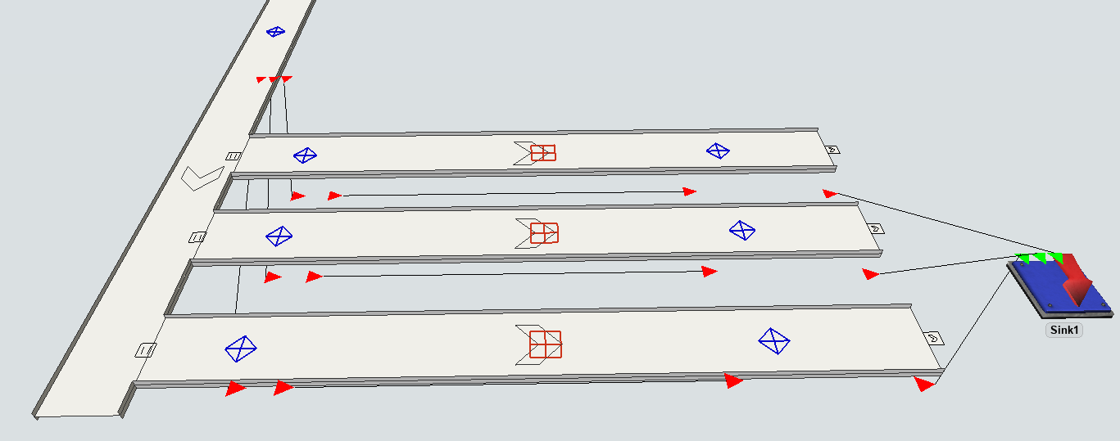
The first conveyor after the source is 30 meters long (Horizontal Length) and connects to the next three conveyors at a 90° angle. When connecting the conveyors, make sure that they have the same height (parameter Z). The detailed locations of decision points, processing stations, and connections are shown in Fig. 3.
Fig. 3 Decision points, processing stations and connections

Flow element
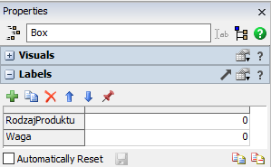
The box element will be used, to which two labels will be added in the Flowitem Bin (Fig. 4):
- ProductType – information about the product number.
- Weight – the weight of each item.
Fig. 4 Product labels

Decision point controlling the flow direction
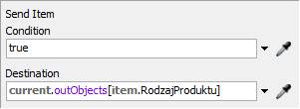
The point is located in front of the side conveyors and is used to control the flow direction. It is named DP1. It is connected directionally to three other points located on the directional conveyors (DP2, DP3, DP4). The triggers define the flow direction: Triggers → On Arrival → Send Item, with the settings shown in Fig. 5. The dump is selected based on the value stored in the ProductType label, assigned when the flow element is generated.

Fig. 5. Setting the decision point

Decision points before service stations
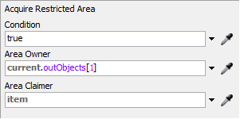
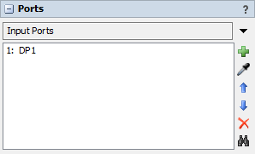
Each of the side conveyors before the service station has decision points (DP2-4). They mark the beginning of the processing zone and should block elements that do not meet the specified conditions from entering each zone. For a flow element to pass the decision point, the designated zone must be clear. The zone occupancy is reported using the OnArrival → Area Restriction → Acquire Area option (Fig. 6). The owner of the zone, i.e. the object that manages it (Area Owner), is the object connected by direction port 1 ( DP1) to the given decision point (Fig. 7).

Fig. 6 Acquire Area Option Fig. 7 Area Owner for DP2
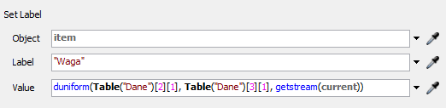
At each of the decision points DP2-4, a value should also be assigned to the Weight label (Fig. 8).

Fig. 8. Label settings Weight on decision points DP2-4

Processing stations
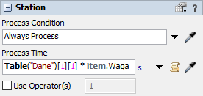
On each side of the conveyor, there is a processing station where the products are processed. The processing time depends on the factor listed in the data table and the Weight label value.
Fig. 9 Processing time settings
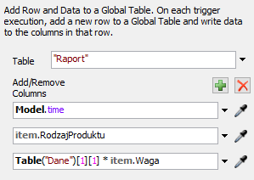
The register of processed products is also updated at the processing stations. To do this, you need to add a Report table with three columns and the On Reset → Delete All Rows option selected. Each time a flow element enters the processing station, the Report table will be updated with a new row. You need to add a trigger On Arrival → Data →Add Row and Data to Global Table and complete the options according to Fig. 10.
Fig. 10. Completing the Report table
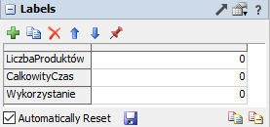
The next step is to collect data on the use of individual stations. To do this, add two labels to each station, as shown in Figure 11.

Fig. 11 Labels on processing stations
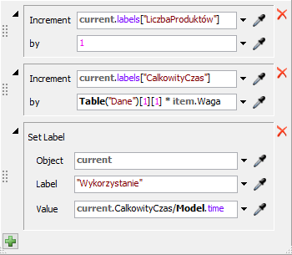
To count processed products, add the On Continue → Data → Increment Value trigger. The value of the Number of Products label will be increased by 1 (Fig. 12) when the flow element is released from the processing station. The Increment Value option will also be applied to the TotalTime label, and the increment will equal the processing time. The third label, Usage, is the quotient of the total processing time and the time read from the model.

Fig. 12. Station usage saving options

Decision points releasing zones
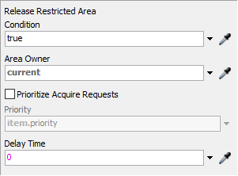
To the zone release points, one trigger should be added, allowing a new flow element to enter after the current element leaves it: Triggers → On Arrival → Area Restrictions → Release Area (Fig. 13). The result of the decision point system responsible for occupying and releasing the zone is shown in Fig. 14.

Fig. 13. Zone release
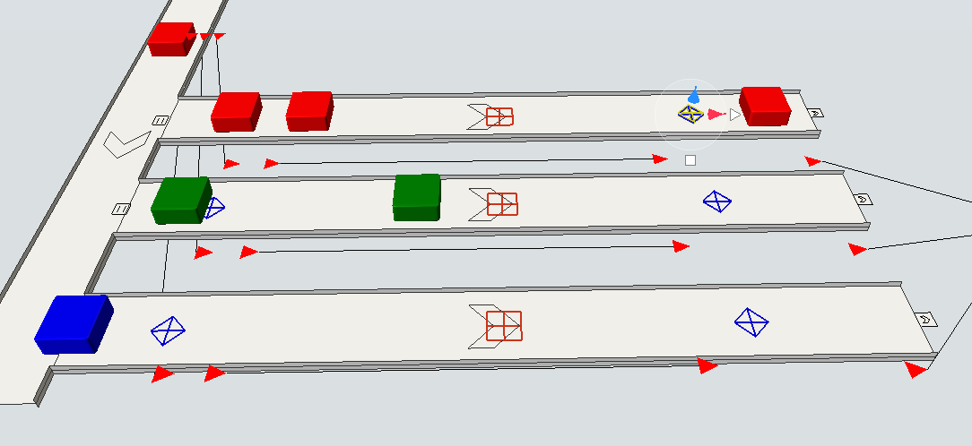

Fig. 14. Decision point operation

