 | 

Work Package 3: Theoretical and practical teaching materials development for transport in Cameroon and the Democratic Republic of Congo

T3.5 Logistic management
Supply management and logistics - Tutorial

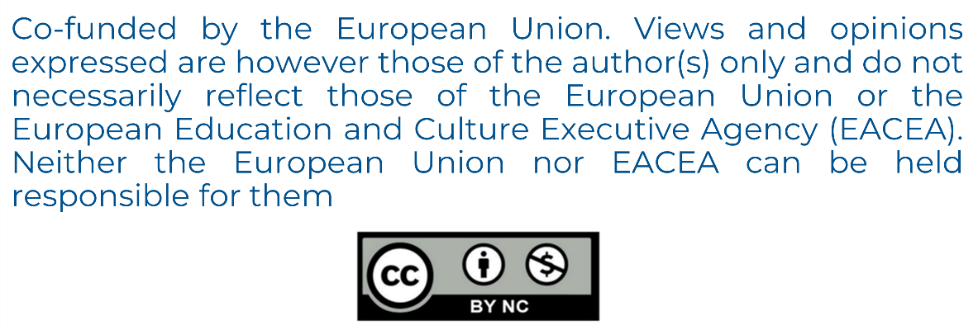

MODELING OF LOGISTICS PROCESSES
ACTIVITY #5

Triggers – introduction

List of authors:
Gdansk University of Technology
Daniel Kaszubowski, Justyna Staszak-Winkler, Wojciech Kustra

Contents:

1 Objective and new skills 3
2 Basic concepts 3
2.1 Simulation events 3
2.2 States 3
3 Triggers 3
3.1 The idea of using 3
3.2 Generating Flow Elements – On Creation 4
3.3 Leaving the facility – On Exit 4
3.4 Communication between objects – On Message 5
3.5 Common triggers 6
4 Action categories available for invocation 6
4.1 Group Date 6
4.2 Control Group 8
4.3 Visual Group 8
4.4 Lists Group 10
4.5 Code Group Snippet 10

Objective and new skills
The task aims to organise the basic concepts used in the program, concerning simulation events and the logic of using object states. Introducing the concept of an object state enables a detailed discussion of the assumptions underlying the use of triggers (Triggers), which allow specific actions or processes to be invoked.
New skills
The concept of a simulation event and state
Principle of using triggers
The ability to indicate where, in the process, selected actions can be initiated
Knowledge of basic actions that can be initiated in selected object states

Basic concepts

Simulation events
An example of real events would be:
- placing the pallet on the rack,
- completion of processing,
- issue of goods from the warehouse.

FlexSim is a program for discrete event simulation (Discrete Event Simulation). Each event starts at a specific moment and lasts for a specific time. The modelled system is therefore represented as a sequence of consecutive events. However, the initial moments of these events are the only times when the object's state can change.

States
Each object in the modelled system is characterised by its current value (state). A machine processing products will have the Processing state. Each object can be in various states characteristic of itself, but only in one at a time.

Triggers

The idea of using
A trigger is a logic of action (an action or operation) that is initiated when a specific state of an object (an event) occurs. Such actions can include, for example, changing the colour of a flow element, changing the value of a label, or adding a row to a table. It can also send a message to another object after a certain action is completed. Each object has its own unique set of triggers. For example, in the Processor object in the Process phase Item, there will be two triggers available, activated in different places (Fig. 1). The triggers available for the Source are shown in Fig. 2. The most important of them will be discussed in the following points.
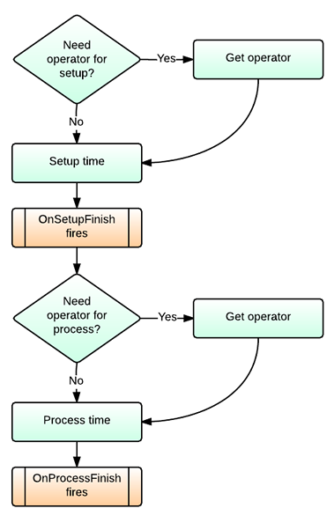
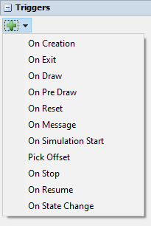

Fig. 1. Examples of triggers . Fig. 2 Triggers for Source

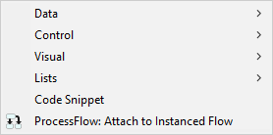
Generating Flow Elements – On Creation
On Creation, the specified operation is activated when the source generates a flow element. The categories of actions shown in Fig. 3 will be discussed in detail later in the material.

Fig. 3 On Creation Section

Leaving the facility – On Exit
The specified operation will be triggered when the flow element leaves the object. The same options as in On Creation are available.

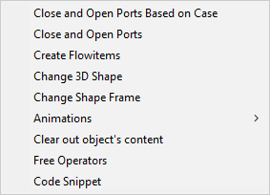
Communication between objects – On Message
On Message runs the selected action whenever the object receives a message. The available actions are shown in Figure 4.
Each sent message has a specific set of parameters (group "Control"). The object receiving the message has access to them and can use them.
Fig. 4. Options for On Message
Sample settings:
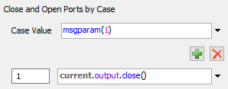
- Close and Open Ports Based on Case – based on the defined value of the given expression (Case Value field), the appropriate action is performed. The settings in Fig. 5 mean that the output port of the current object is the current one. output. close() will be closed if the object receives a message in which the value of the first parameter msgparam (1) will be equal to 1.
Fig. 5 Close and Open Ports Settings
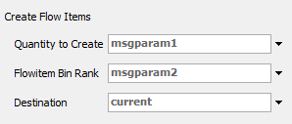
- Create Flow Items – allows you to generate a flow item. The number of items to create is specified in the Quantity to Create field. The type of the flow item (Flowitem Bin Rank) is given as the next numeric value in the list of available items in the Flowitem Bin section. The destination determines the place where the objects appear. The values of these parameters must be related to the parameters of the received message (Fig. 6)
Fig. 6. Create Flowitems settings
- Clear out object content – removes all elements that are on the object at the time the message is received (Fig. 7).

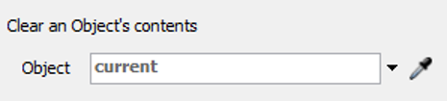
Fig. 7. Clear out objects content option

Common triggers
Many objects have very similar triggers, especially if they belong to the same category. Therefore, in addition to the triggers already mentioned, it is common to use:
- On Entry – allows the execution of the given logic when the element enters the given object. The command is not available for the source, because it is the beginning of the system.
- On Setup Finish – triggers a specific action after the object is re-armed. Occurs on Processor, Combiner, and Separator.
- On Process Finish - calls action when the processing time of an element has expired. Occurs on Processor, Combiner, and Separator.

Action categories available for invocation

Group Date
It is possible to parameterise flow elements and/or model objects. The most commonly used options are:
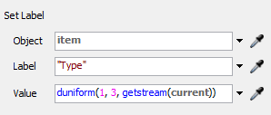
- Set Label – allows you to change the value of an existing label or add a new label with a given value. In the Object field, you specify the object to which the label is assigned, in the Label field, you define the name of the label, and in the Value field, its value (Fig. 8).
Fig. 8 Set Label option
- Set Label and Colour – works identically to Set Label, but a colour is automatically added to the selected flow element. It is set based on the numeric value of the label, from which the colour number in the RGB palette is selected.
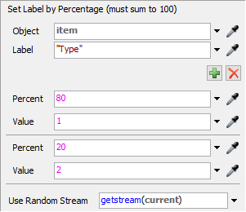
- Set Label by Percentage – allows you to change the label value based on the percentage distribution. Use the green button to add more cases (Fig. 9).

Fig. 9 Option Set Label by Percentage
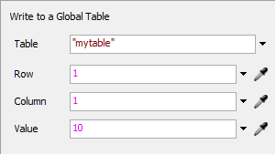
- Write to Global Table – writes the specified value (Value field) to the selected global table (Table field). In the Row fields and Column – specify the row and column number in which the saved value will be located (Fig. 10).
Fig. 10 Option Write to Global Table
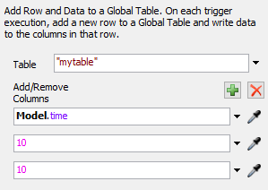
- Add Row and Data to Global Table – allows you to add another row to the given global table (Table field) and fill the next cells with appropriate values according to the established column layout. The green cross adds fields corresponding to columns in the target table, in which the method for entering values is defined (Fig. 11).
Fig. 11 Add Row and Data to Global Table option.
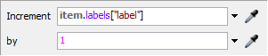
- Increment Value – allows you to change the value of the expression given in the Increment field by the value given in the by field (Fig. 12).
Fig. 12. Increment Value option

Control Group
The commands in this group allow you to control objects. The most commonly used are:
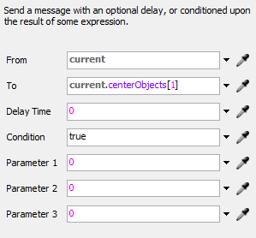
- Send Message – allows you to send a message with specific parameters from a given object. You define the object that sends the message (From) and the object that receives it (To). In the Condition field, you can specify the condition that must be met for the message to be sent, while in Delay Time, you can specify the delay time for sending the message. The message parameter is given in the Parameter 1-3 fields (Fig. 13).
Send Message Settings
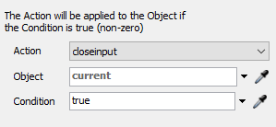
- Close and Open Ports – allows you to close or open the input or output ports of a given object. The action to be performed is selected from the Action field. The target object is indicated in the Object field, while the condition to be met is indicated in the Condition field (fig. 14).
Fig 14 Close and Open Ports

Visual Group
Visual collects actions related to the graphical settings of both flow elements and model objects. The most commonly used options are:
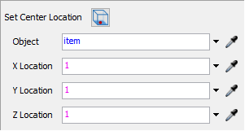
- Set Location – allows you to change the position of the object indicated in the Object field. The position is specified in the XYZ reference system (Fig. 15). The XY coordinates define the position of the centre of the lower base of the indicated object.
Fig. 15 Set Location
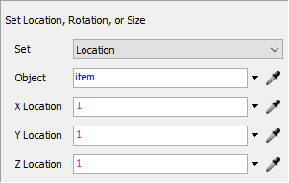
- Set Rotation, Size, and Location – allows you to rotate, change the size, and location of the object (Fig. 16). The appropriate option is selected in the Set field.

Fig. 16 Set Rotation, Size, and Location
- Set Colour by Case – adds a colour to the selected object (Fig. 17). The colour is assigned based on the value of the expression in the Value field. Colour numbers can also be assigned manually by adding subsequent items using (Fig. 17).
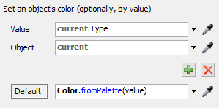
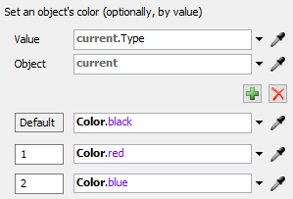
Fig. 17 Set Rotation, Size, and Location Fig. 17 Options adding colours
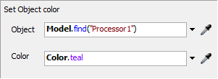
- Set Object Colour – allows you to set the colour of the object selected in the Object field (Fig. 18).

Fig. 18 Set Object Colour
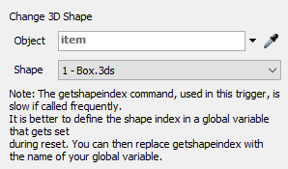
- Change 3D Shape – allows you to change the shape of the object indicated in the Object field to the shape available on the list in the Shape field (Fig. 19).

Fig. 19 Change 3D Shape.
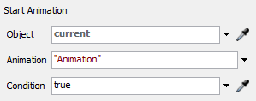
- Start Animation /Stop Animation – allows you to start or stop the indicated animation (Fig. 20). You can indicate the animation by entering its name or its assigned number, e.g., the animation of opening doors in a truck is called OpenDoorsStopped and has the number 1.
Fig. 20 Start Animation /Stop Animation

Lists Group
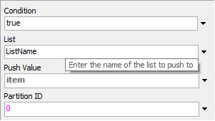
Actions allow you to add or remove items from the list. Adding is triggered by Push to List, removing by Pull From List (Fig. 21).

Fig. 21 Push to List option

Code Group Snippet
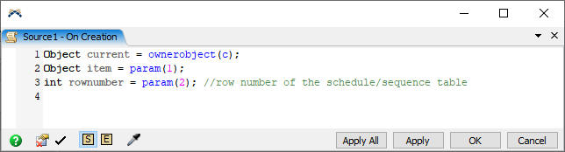
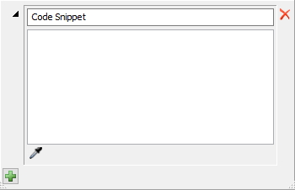
The action lets you save your own logic using the built-in FlexScript language (Fig. 22). The same effect can be achieved by selecting the icon next to the selected trigger, which opens the trigger's script for direct editing, as shown in Fig. 23.
Fig. 21 Conde Snippet Window Fig. 22. Direct script editing

