 | 

Work Package 3: Theoretical and practical teaching materials development for transport in Cameroon and the Democratic Republic of Congo

T3.5 Logistic management
Supply management and logistics - Tutorial



MODELING OF LOGISTICS PROCESSES
ACTIVITY #4

Quality control station

List of authors:
Gdansk University of Technology
Daniel Kaszubowski, Justyna Staszak-Winkler, Wojciech Kustra

Contents

1 Objective and new skills 3
2 Assumptions and input data 3
3 Object parameters and flow logic 4
3.1 Flow element 4
3.2 Source 4
3.3 Product flow separating buffer 5
3.4 Processing stations 6
3.5 Quality control station 6
4 Register of defective products 7
5 Analysis of simulation results 9
5.1 Buffer Occupancy 9
5.2 Machine load 9
5.3 Defective products 10

Objective and new skills
The task is intended to consolidate the ability to configure the logic of element flow using solutions that simulate the quality control system's operation. This allows callbacks to be introduced into the model using conditional formulas and data stored in global tables.
New skills
Introduction of reverse flow logic in the model
Saving item statistics in global tables
Creating new types of graphs for analysing simulation results

Assumptions and input data
- Elements appear in the system according to an exponential distribution with a scale parameter value of 10.
- Each type of product is processed at a dedicated service station. The processing time is fixed at 10 seconds.
- After processing, the products are collected in a common buffer before the quality control station.
- The quality control time of one element is between 5 and 10 seconds.
- It was assumed that 20% of the products do not meet quality standards and must be reprocessed.
- A product that fails to meet quality standards again is removed from the system.
- All parameters are saved in the global table.
- A register is kept of products that do not meet quality standards.
- The load on buffers and machines will be analysed.
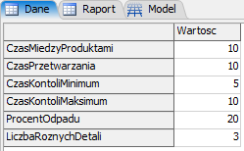
The input data are collected in the global Data table (Fig. 1), while the target model layout is shown in Fig. 2.

Fig. 1. Model parameters in the Data table
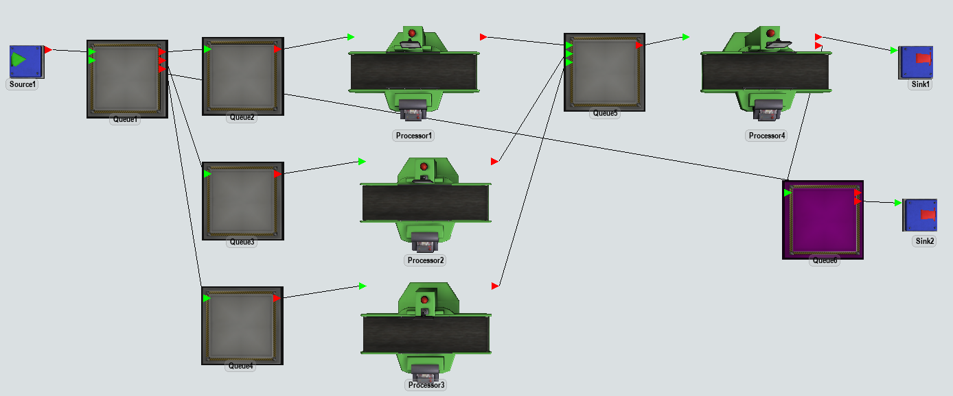
Fig. 2. Target model layout

Object parameters and flow logic

Flow element
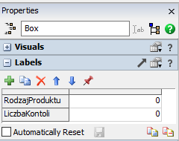
The model will use the standard Box element. Two numeric labels should be added to it (Fig. 3):
- ProductType – the label will store the product number.
- Number of Controls – the label records the number of tests on a given element.

Fig. 3 Data labels

Source
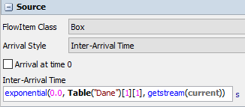
The source will generate flow elements according to the Inter- Arrival Time option. The default exponential distribution formula will be modified by inserting the scale parameter value from row 1 of the Data table (Fig. 4).
Fig. 4 Source settings based on the Data table
Next, go to the Triggers → Data → Set Label and Colour section to assign a value to the ProductType label. The product colour will be added automatically. The modification to the record will concern the formula in the Value field, which will retrieve the number of different product types from the Data table (Fig. 5).
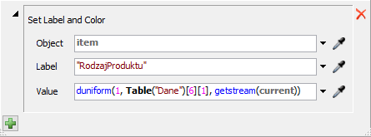

Fig. 5 Settings Set Label and Colour

Product flow separating buffer
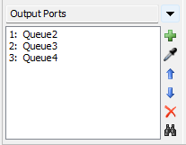
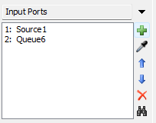
Directly behind the source is the Queue1 buffer, which divides the product stream. It is necessary because it allows for the reprocessing of products that did not meet quality standards. This can be seen in the list of input and output ports (Fig. 6). Both products generated in Source1 and products that did not pass quality control on the Processor4 machine and were sent for reprocessing can be sent to Queue1.

Fig. 6 Set Label and Colour Settings
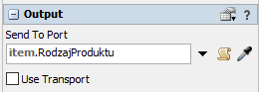
The rules for moving flow elements to subsequent objects can be set in Send to Port by entering the item entry—productType (fig. 7).
Fig. 7 Send To Port Setting
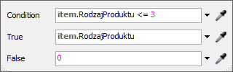
You can also consider using the Conditional Port option (Fig. 8). If the value of the ProductType label is less than or equal to 3, it goes to the output port numbered according to the label value. Otherwise, the product goes to the first free output port (value "0" in the False field).
Fig. 8 Alternative Send to Port setting.

Processing stations
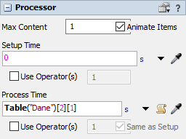
The processing station settings only require entering a reference to the appropriate Data table cell in the Process Time field (Fig. 9).

Fig. 9 Process Time settings

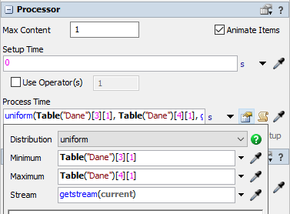
Quality control station
Quality control is performed on Processor4 stations. Its time is set to 5-10 seconds. Select Process Time → Statistical Distribution → Uniform, i.e., uniform continuous statistical distribution. The value of the limit parameters is read from the appropriate fields of the Data table (Fig. 10).

Fig. 10 Quality control time settings

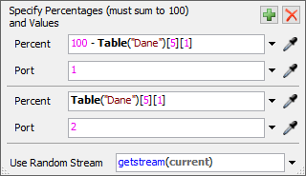
Elements from the quality control station will be directed either to the system output Sink1 or to the Queue1 buffer for reprocessing after defects are detected. Elements can be separated by using the Send to Port → Random → By Percentage option, where data from the Data table regarding the percentage of defective products (waste percentage) will be used (Fig. 11).
Fig. 11. Quality control station output settings

The quality control system requires the marking of items already checked. As indicated in the assumptions, products that fail quality control again are removed. Each product has a label Number of Controls, which will be updated after passing the quality control station. Select Triggers → On Process Finish → Data → Increment Value. Then you need to select the Labels option expression to be increased, along with the increase value specified in the by field (Fig. 12). The final formula is shown in Fig. 13.
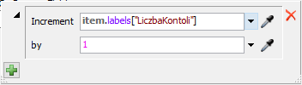
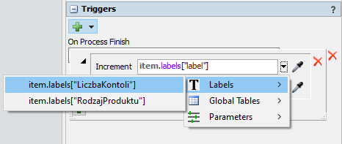
Fig. 12. Increment Value option settings Fig. 13. The final form of the formula

Register of defective products
A table (register) will be created in the model to record information about defective products. It will be created in the same way as the Data table, i.e., by going to Toolbox → Global Table. The new table should be named Report (Fig. 14). Three columns will store information about:
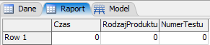
- the time at which the defective product appeared,
- type of product,
- Number of quality tests for this product.
Fig. 14 Table Report
The table will be filled in dynamically during the simulation. For this purpose, it is necessary to indicate the moment (object) at which information about defective products will be collected. Given the model's principles and target structure, it seems reasonable to indicate either the re-entry of the defective product into the Queue1 separating buffer or its exit from the Processor4 control station. However, each indicated event applies to both correct and defective products.
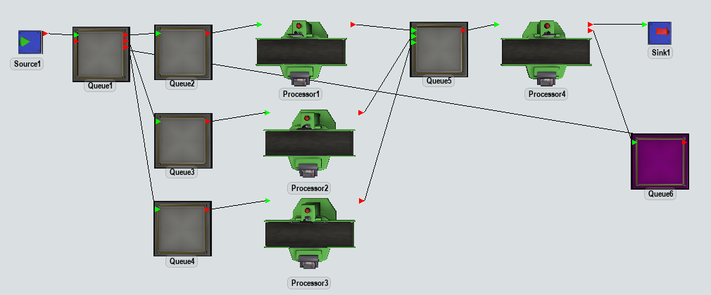
Therefore, a simple solution to the problem is to add an auxiliary object that collects information about defective products. This will be Queue6 between the control station and Queue1. This object acts as a virtual element of the model introduced solely for analytical purposes (Fig. 15).

Fig. 15. Helper object Queue6
On Queue6, you need to choose Triggers → On Entry → Data → Add Row and Data to Global Table. Each time a product hits this buffer, another row will be added to the selected table. The configuration of the function (Fig. 16) consists of indicating the name of the modified table (Table) and adding the appropriate columns, in this case, item.ProductType and item.ControlNumber. Option Model. Time is the default reference that returns the event time. The result of the function is shown in Fig.17. It is worth remembering to select the On Reset option in the Report table settings → Delete All Rows. The table updates automatically, but without resetting, the results of subsequent simulations would be added as additional rows to the end of the table.
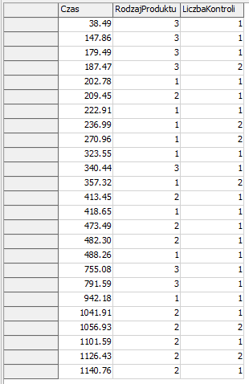
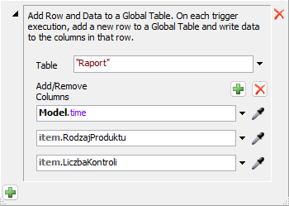
Fig. 16. Table completion function

Fig. 17. Fragment of the completed Report table
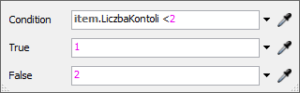
The last stage in building the model is to remove products that have again failed to meet quality standards from the system. This can be easily solved by adding a second output Sink2 to the auxiliary queue Queue6, which will allow for the division of the stream of elements. The flow logic on this buffer will be defined as Send to Port → Conditional Port (Fig. 18).
Fig. 18. Output setting on Queue6

Analysis of simulation results

Buffer Occupancy
The model will be run for 8h (28800 sec). The analysis will include buffer occupancy and the number of products removed from the system. First, you need to add a new Dashboard → Add Blank Dashboard, which will display charts for all buffers.

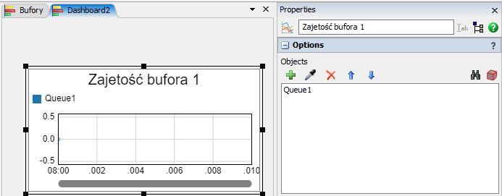
Then, from the Content group, select Content → Line Chart, add it to the Dashboard panel, change the name, and add the appropriate object to the chart (Fig. 19). The name is changed in Properties, while objects are added in Options using the green cross.
Figure 19. Buffer usage line graph settings
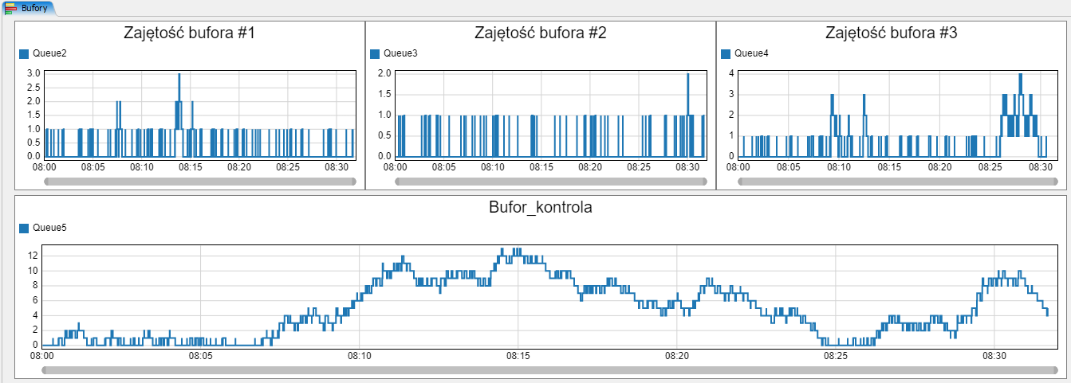
After repeating the described steps for all buffers in the model and running the simulation, the result is shown in Fig. 20.
Figure 20. Results of buffer occupancy analysis during simulation

Machine load
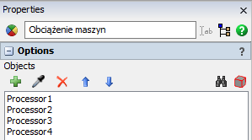
The machine load will be presented in a pie chart. You should add another Dashboard window, then the State → State → Pie Chart group. The statistics of all machines will be placed on one diagram after adding them in the Objects options (Fig. 21). The simulation result is shown in Fig. 22
Fig. 21 Machine Load Chart
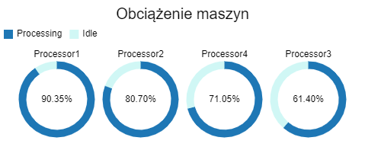

Fig. 22. Simulation result – machine load statistics

Defective products
The following values should be analysed:
- The number of products generated without the need for correction.
- The number of products generated for which correction was required.
- Number of invalid (rejected) products.
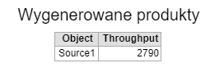
Products generated by the source can be read from its statistics and transferred to the Dashboard. In the section Statistics → Throughput → Pin to New Dashboard → Output → Table. After the simulation is finished, the result will look similar to Figure 23.

Fig. 23. List of generated elements
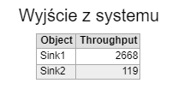
Similarly, you can see how many items were transferred to Sink1 (correct products) and Sink2 (rejected products). In the Output tab, you must select the category of the same name, then the Table format.
Figure 24. List of system outputs
The total number of objects that left the system (2787) is smaller than the number of generated objects (2790). This is because part of the element, at the time the simulation ends, is still on objects, e.g., workstations.
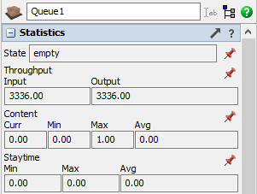
Another issue is the number of items that require correction. This can be read from the statistics of Queue1, i.e., the separating buffer (Fig. 25). It produced 3336 items, which, with 2790 generated by Sink1, gives 546 products requiring correction. This can also be confirmed by subtracting the number of rejected items (119) from the total number of entries in the reporting table (665), where information about all items requiring correction, both once and repeatedly, was recorded.
Fig. 25 Queue1 statistics

