 | 

Work Package 3: Theoretical and practical teaching materials development for transport in Cameroon and the Democratic Republic of Congo

T3.5 Logistic management
Supply management and logistics - Tutorial



MODELING OF LOGISTICS PROCESSES
ACTIVITY #2

Building the element flow logic

List of authors:
Gdansk University of Technology
Daniel Kaszubowski, Justyna Staszak-Winkler, Wojciech Kustra

Contents:

1 Objective and new skills 3
2 Basic principles of creating flow logic 3
2.1 Send to Port 3
2.1.1 Random option 4
2.1.2 Option By Percentage 4
2.1.3 Round Robin Option 4
2.1.4 Shortest Queue Option 4
3 Flow elements 5
3.1 Creating flow elements 5
3.2 Labels – Labels 5
3.3 Giving Value to Labels - Triggers 7
4 Flow logic using labels 8
4.1 By Expression Option 8
4.2 Conditional Port Option 8
4.3 Port by Case Option 9
4.4 Do Not Release Option Item 9

Objective and new skills
The task aims to master the ability to create the logic of the flow of elements in the model using built-in object control functions and using labels assigned to flow elements. The information obtained is necessary to create advanced rules for controlling the flow of elements, which are required in further classes.

New skills
Using basic functions to control the flow of elements in model objects
Basic ability to create and configure flow elements
Ability to create labels assigned to flow elements
Assigning values to created labels
Fundamentals of flow control using label value-based functions

Basic principles of creating flow logic

Send to Port
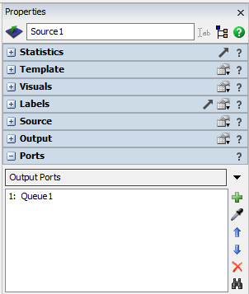
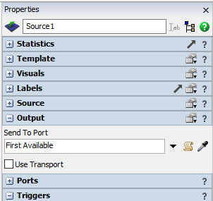
Basic information about the flow structure is provided by the list of input, output, and central ports for each object (Fig. 1). The rules governing the flow of elements between objects are established by commands that control output ports. Information about which output port is to be selected is contained in the Output section of each element, and the Send to Port command (Fig. 2). Its details will be discussed in the following subchapters.

Fig. 1 Port list Fig. 2 Output port selection control
By default, Send to Port is set to First Available, which means the item will be sent to the first available output port. You can enter the port number here (from Output Ports) to which the flow elements are to be sent. Entering "0" selects the first available option.

Random option
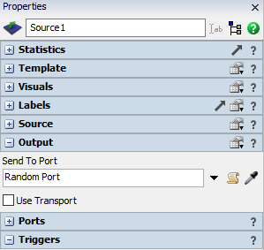
The Random → Random Port option is one of the simplest ways to split the input stream. The effect will be a random selection of the output port by subsequent elements (Fig. 3).

Fig. 3 Random selection of output port

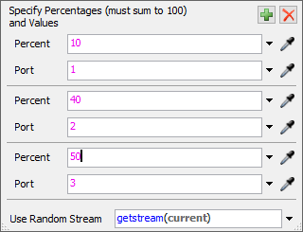
Option By Percentage
After selecting the Random → By Percentage option in Send to Port, a window appears allowing you to divide the output stream by percentage to individual ports – in this case, three (Fig. 4).

Fig. 4. Percentage distribution to output ports

Round Robin Option
The Random → Round Robin option in Send to Port allows you to assume a specific sequence of output ports. The flow elements go to the output ports in sequence. When three output ports are available, the first element goes to port 1, the second to port 2, the third to port 3, and the fourth to port 1 again. After selecting the Round Robin option, if available, blocked ports will be skipped.

Shortest Queue Option
The Shortest Queue option is located in the Queue Size group. When selected, flow items will be sent to the objects (buffers, machines, etc.) with the fewest other flow items (i.e., the smallest queue).
You can also select Shortest Queue if Available. It allows bypassing unavailable target objects. The object with the shortest queue may not accept any further elements, e.g., because the buffer is full. In this situation, the element will be redirected to another queue.
Longest Queue, if the option Available is available, gives the opposite result to the previous ones. Objects with the longest queue are selected first.

Flow elements

Creating flow elements
A flow element is any element subject to manipulation in the model, e.g., a pallet or a box. Flow elements are generated in the Source object (Fig.5). In its properties, in the tab of the same name, you can select the flow element used in the model (Source → FlowItem Class). Details of their configuration will be discussed later in the course.

The preview of all available flow elements (Fig. 5), along with the possibility of their further editing, is possible after selecting FlowItemBin on the top bar of the program, in the upper right
corner.

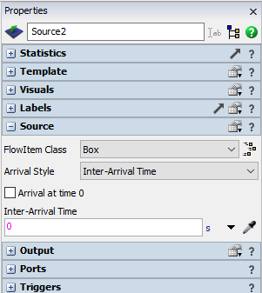 | 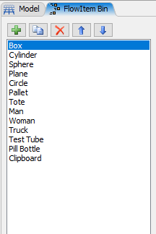
Fig. 4. Selecting the flow element – Box | Fig.5 FlowItemBin

Labels – Labels
Labels added to flow elements control their behaviour in the model. They let you assign different features to each element, enabling you to trigger model behaviour based on those elements' values. For example, you can assign labels to generated elements, defining their colour or mass, so they are directed to the appropriate storage rack or placed on the appropriate conveyor belt.
The label value can be changed for each object in the model (Triggers option), while label names should be added to flow elements at the first stage of model building, i.e., in the FlowItemBin window. You should select the object there, then in the Labels tab, select the green cross (fig. 6).
The following types of labels are most commonly used:
- Label Number – the label contains numeric values,
- String Label – label with text values,
- Pointer Label - the label contains a reference to a specific object in the model (its address).
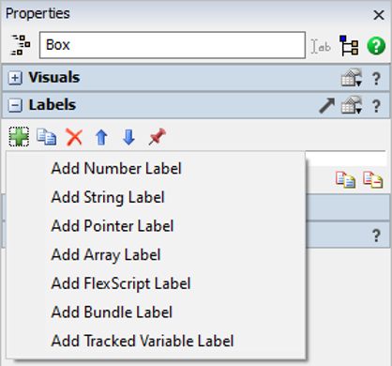
Fig.6 Adding labels
A good practice when creating labels is to use a uniform naming scheme, e.g., all labels with a capital letter (Weight). If the name consists of several words, each of them starts with a capital letter (TypeProduct).
In label names:
- do not use spaces,
- no special characters are added (!,@,%, etc.),
- You cannot start a character with a digit.
For the task, two numeric labels, Weight and ProductType, should be added. Their initial value will be 0 (Fig. 7).
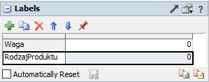
Fig.7 Adding labels

Giving Value to Labels - Triggers
Each object has its own set of triggers that allow it to execute an appropriate action when an appropriate event occurs.

In the task, each item generated by Source will be assigned a value that specifies its type and weight (and optionally its colour, based on information about the product type).

In the source properties, select Triggers, then On Creation → Data→Set Label and Colour (Fig. 8). In the window, you can assign label values:
- Object – specifies what the label will be assigned to; by default, it is item, i.e., the current flow element,
- Label – indicates the name of the label; the default value is "Type", but once you've added labels to flow elements, their names appear in the list to choose from.
- Value – specifies the value of the label; by default, the notation duniform (1,3,getstream(current)) appears, which means a value generated from a discrete uniform distribution on the range from 1 to 3.
Similarly, the Weight label will be assigned. With the On Creation option, select the green cross, then choose Data→Set Label. In this case, only the value will be added, without specifying the colour (Fig. 9). It is assumed that the product weight will be in the range of 1-30 kg.

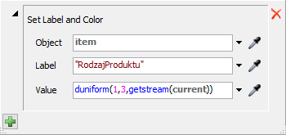
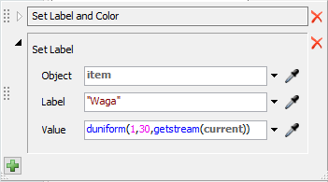
Fig.8 Assigning value - ProductType | Fig.9. Assigning Value - Weight
The results of the introduced changes are shown in Fig. 10. Each flow element has a different ProductType label value in the range 1-3. Additionally, the elements have a different colour from the RGB palette, in which 1 corresponds to red, 2 to green, 3 to blue, etc. The elements also have an assigned weight.

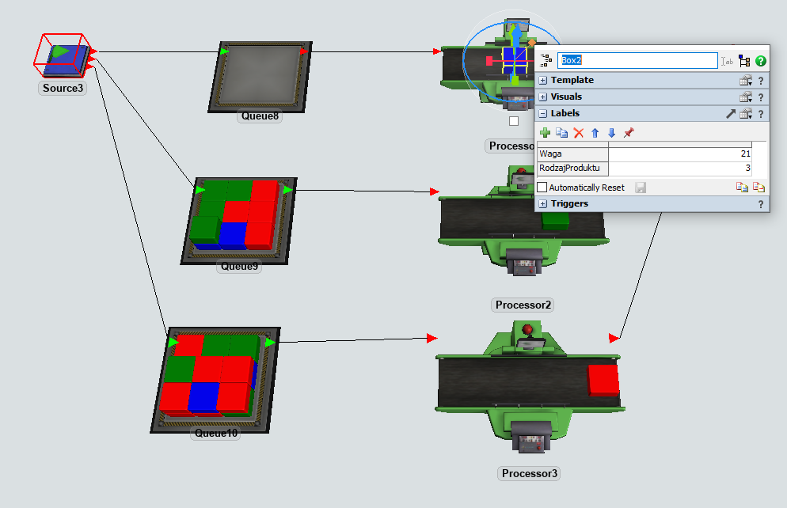
Fig.10. Example of an element with assigned values of the Weight and Product Type labels.

Flow logic using labels

By Expression Option
This option can be used, for example, when products with a specified number on the label are to be sent to buffers before machines assigned to a given item. In the Send to Port section, the By Expression option allows you to enter a function or select one from a list. It indicates the output port number to which the flow element will connect.

The Product Type Label is located on the current element item. To refer to it, the notation item. ProductType is used. In this case, it means a value in the range 1 - 3. Therefore, using this expression, flow elements 1-3 will be sent to the output ports corresponding to their numbers. The result is shown in Fig.11.

Conditional Port Option
This option allows you to differentiate the destination port for flow elements depending on the selected label value range. In this example, it is assumed that products are sent to the appropriate ports depending on the Weight label value. Products weighing less than or equal to 15 kg are sent to port 1, while the remaining products are sent to port 2. The condition is specified in the Condition field. If it is met (True), the element will be sent to port 1; otherwise (False), to port 2. The notation of this option is shown in Fig. 12.

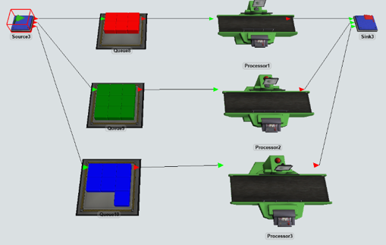
Fig.11 By Expression option
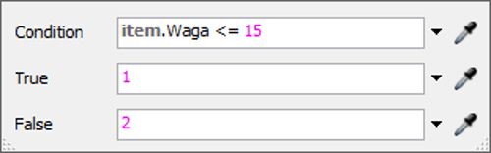
Fig.12 Conditional Port Option

Port by Case Option
Port by Case allows you to specify the port number of the appropriate output port depending on the value of the entered expression (Fig. 13). In the Value field, you enter the selected expression – the example uses item. ProductType. Subsequent cases (Case) refer to the individual values of this expression. They are assigned selected output port numbers. New cases are added with a green cross. There is always one default case, Default. If a conventional port 0 is assigned to it, it means that if an element appears in the model that is not defined by the value of the entered expression (here: without the ProductType label), it will go to the first free output port.

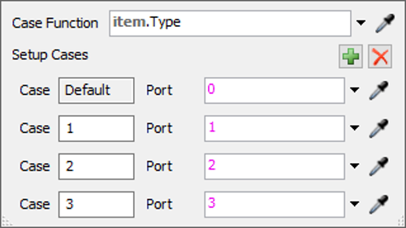
Fig.13 Port by Case option

Do Not Release Option Item
Do Not Release Item allows you to block a flow element through a given object. Blocking all elements on an object is achieved by entering the value "-1" in Send To Port. If you want to block only selected elements, use the Port by Case option: in the Default case, -1 is assigned, and for the remaining cases, the appropriate ports are assigned. In the modified example (item.ProductType), you can, e.g., block element 1 by directing elements 2 and 3 to ports (machines) 1 and 2 (Fig. 14). Elements 1 (red) remain on the buffer, elements 2 and 3 (green and blue) go to the appropriate machines (Fig. 15).

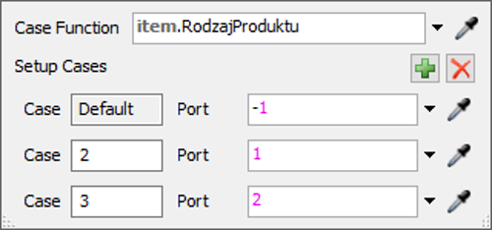
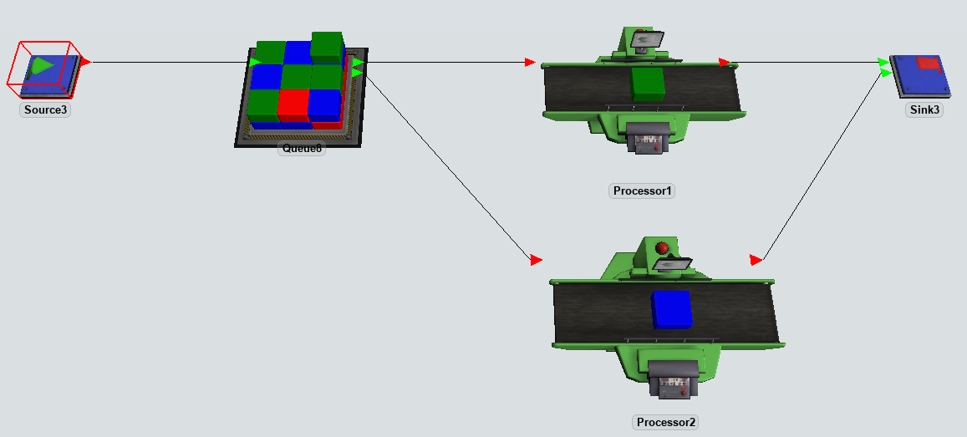
Fig. 14 Do not release the settings Item.
Fig.15. Result of using the Do Not Release option for the Item

