 | 

Work Package 3: Theoretical and practical teaching materials development for transport in Cameroon and the Democratic Republic of Congo

T3.5 Logistic management
Supply management and logistics - Tutorial



MODELING OF LOGISTICS PROCESSES
ACTIVITY #1
Basics of 3D modeling

List of authors:
Gdansk University of Technology
Daniel Kaszubowski, Justyna Staszak-Winkler, Wojciech Kustra

Contents:

1 Objective and new skills 3
2 Basics of creating a model 3
2.1 Procedure 3
2.2 Directional and central ports 4
3 Introductory model 6
3.1 Assumptions 6
3.2 Building the model 6
3.2.1 Sources 6
3.2.2 Buffers and packaging machine 8
3.2.3 Network Nodes (NetworkNode) 9
3.2.4 Warehouse rack and rack stacker 9
3.2.5 Unpacking machine - Separator 10

Objective and new skills
The task aims to master the basic principles of 3D process modelling, work with objects, and become familiar with the program's layout and key functions.
New skills
3D model creation procedure
Contents of object libraries
Modification of basic object parameters
Central and directional ports and connections
Using operators
Formatting the workspace view
Running the simulation

Basics of creating a model

Procedure
Creating a model in 3D mode includes three basic groups of activities (Fig. 1), which will be discussed in detail in the next classes.
Fig.1. Principles of creating a 3D model
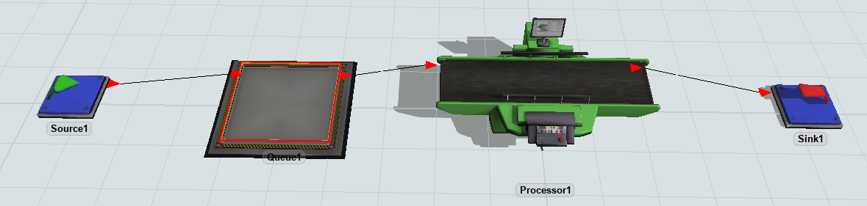
An example arrangement of connected objects is shown in Fig. 2.
Fig.2 Examples of objects in the 3D model
The Properties dialogue box will appear. (Fig. 3), allowing you to change its position in the XYZ system, rotation, and size. You can also configure other parameters there, such as labels, the type of generated flow element (for the Source), associated ports, and output handling (Output). Some objects, e.g., Processor, have specific functions (Fig. 4).
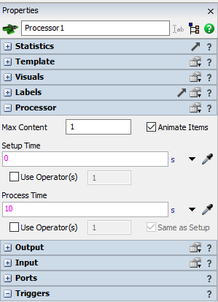
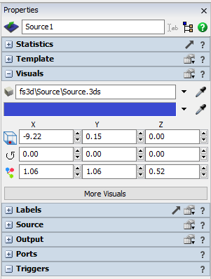
Fig. 3. Properties window for source Fig. 4. Properties window for device (Processor)

Directional and central ports
When you select each object, a white arrow symbol (direction port) and a white square symbol (central port) will appear on it.

Directional ports are used to create connections that indicate the direction of flow between connected objects.

Central ports allow you to add an operator to an object (Use Transport option). This can be a human, an AGV vehicle, or an industrial robot.

Directional connections are visible as red arrows between elements in Fig. 6. They are created by selecting the white triangle and dragging the yellow line towards the target element. The same effect can be achieved with the "A" key and pointing at the start and end objects.

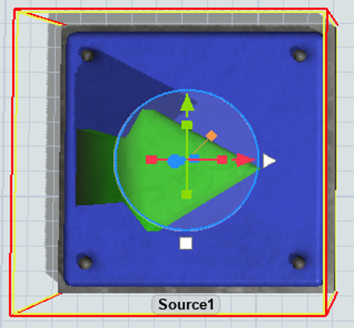
Fig. 5 Directional and central ports
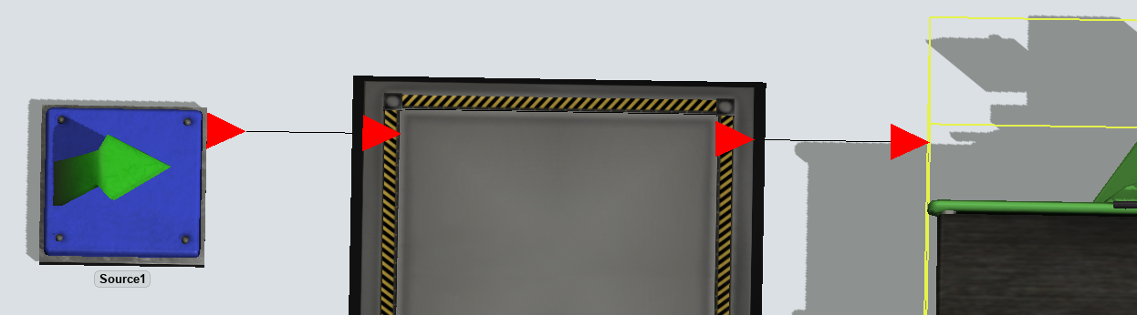
Fig. 6 Directional connection symbols
Operators added via the central port move flow elements between stations or handle them (Processor). Central connections are created in a similar way to directional connections. After selecting the white square, you need to indicate the operator. The same can be achieved with the "S" key. The order of selecting objects is irrelevant. In addition to creating a connection, you need to select the Use Transport option in the handled element (Fig. 7). The result of connecting the operator via the central port is shown in Fig. 8.
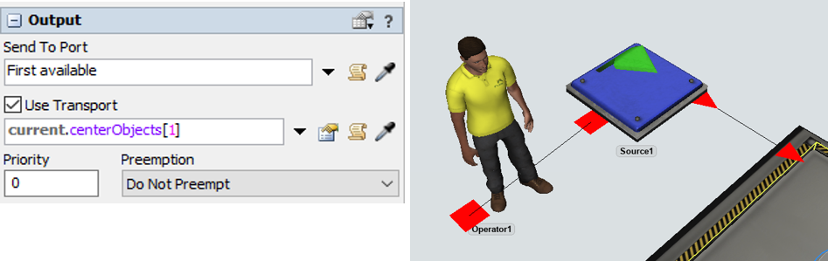

Fig. 7 Use Transport option Fig. 8. Operator connected to the source (Source)

The effect of connecting the central operator, Operator, to the Source, which in turn is connected directionally to the Processor station, is shown in Fig. 9.
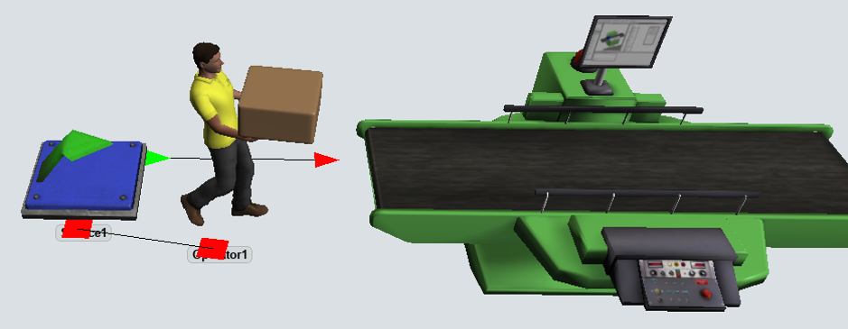
Fig. 9 Operator servicing the Source

Introductory model

Assumptions
The construction of the introductory model is intended to provide orientation to the program's basic functions and familiarise users with its capabilities. The exact configuration of the model and definition of the flow logic will be the subject of further classes.
The model includes a system for receiving and issuing products from the warehouse, as well as for completing and dismantling pallets. The following assumptions were made for its construction:
- pallets containing 8 products appear at the entrance on average every 10 seconds,
- the pallets are transported by a forklift to the storage area and placed in the intermediate area next to the storage rack,
- from the intermediate zone, the stacker crane picks up pallets and places them in a randomly selected location on the warehouse rack,
- 5 minutes after the pallet is put down, it is picked up and transferred to the unloading zone,
- A second forklift performs transport to the unloading zone.

Building the model

Sources
The model includes two sources that generate pallets and products separately (No. 1 and No. 2, respectively). The configuration parameters of both sources are shown in Fig. 11.

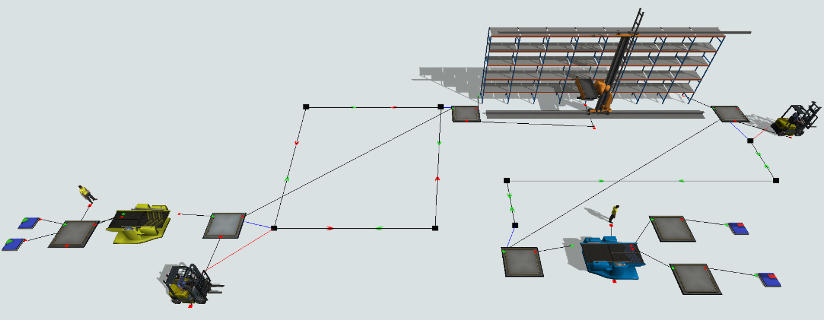
Figure 10 shows the structure of the target model, which will be discussed in the next steps.
Fig. 10. The structure of the introduction model
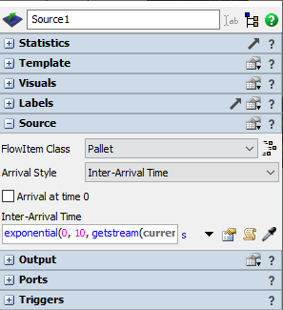
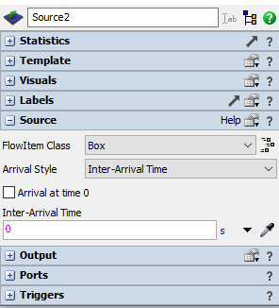
Fig. 11 Source1 and Source2 configuration

Buffers and packaging machine
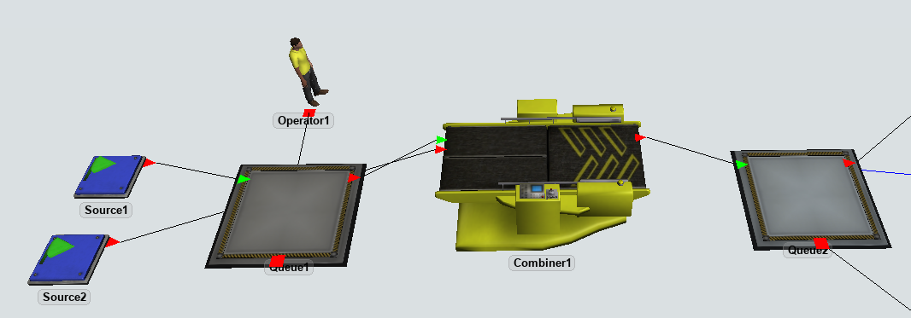
(Queue) , a packaging machine (Combiner), and an operator are added. The two previously inserted sources (S1 and S2) should be connected to the next objects via the direction ports, as shown in Fig. 12. The operator is connected to Queue1 via the central port.
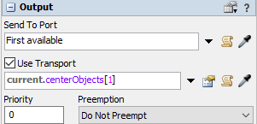
Fig. 12 Buffers, operator, and packaging machine
Queue1 settings are shown in Fig. 13. It is necessary to connect to Operator1 via the central port.
Queue1 Settings
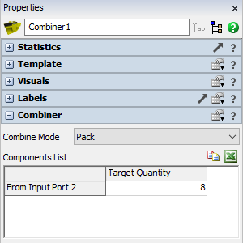
The packaging machine settings (Combiner) are shown in Fig. 14. It is assumed that the pallet contains 8 products. They are delivered from input port no. 2, i.e., the one connected to Source2. The number of elements from port 1 (Source1) is 1 by default.

Fig. 14 Combiner1 Settings
Behind Combiner1, there is a second buffer, Queue2. It should be connected via the central port to the forklift Transporter1, and the Use Transport option should be selected, just like for Operator1.

Network Nodes (NetworkNode)
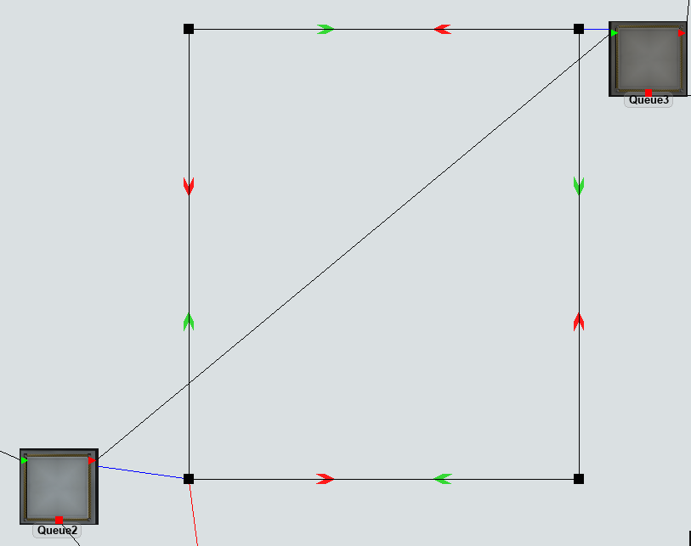
After Queue2, four network nodes should be added as shown in Fig. 15. They are connected in the direction shown. Two green arrows on the connection indicate bidirectional traffic. To turn off one direction, use the "Q" option. The nodes should be connected directionally to the appropriate buffers; the connection will appear as a blue line.

Fig. 15 Combiner1 Settings

Warehouse rack and rack stacker
(Rack) A stacker crane (ASRS vehicle) is added to the model, as shown in Fig. 16. It also shows additional elements of the model. Buffers in front of and behind the rack are necessary. The pallet flow buffer 3 → rack → buffer 4 provides directional connections.

The stacker crane control ensures that it is linked to the rack via the central port and that the "Use Transport" option is selected on the rack. Similarly, the Queue3 buffer should be linked to the stacker crane in front of the rack. In this way, all objects from which ASRS will handle the elements exit.
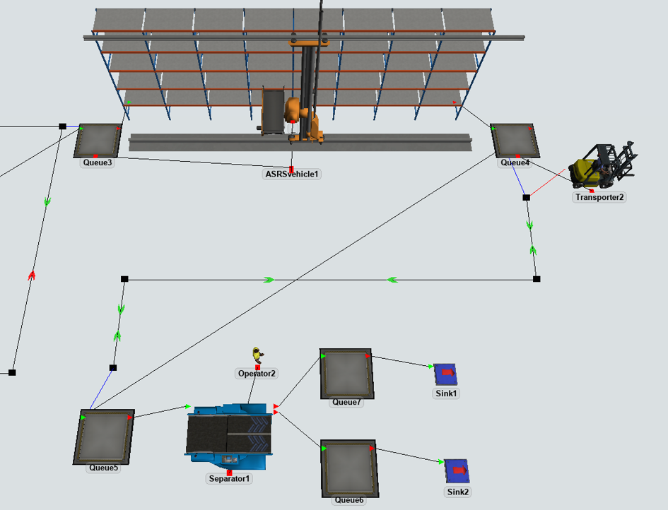
Fig. 16 Warehouse rack, stacker crane, and unpacking machine (Separator)
Next, the forklift Transporter2 is added to transport pallets from Queue4 to the unloading zone (Queue5) and then to the separator. The forklift moves along the path of nodes as in Fig. 16. It is important to remember:
- connection of the central port Queue4 and Transporter2,
- selecting " Use Transport" on Queue4,
- the Queue4 and Queue5 direction port ,
- connecting network nodes with appropriate objects (Queue4 and Queue5)

Unpacking machine - Separator
The separator is operated by Operator2, connected via the central port. The object's default settings have been maintained. After unloading, the pallets will be placed on the buffer connected to output port 1, while the products will be placed on the buffer connected to output port 2.

