 | 

Work Package 3: Theoretical and practical teaching materials development for transport in Cameroon and the Democratic Republic of Congo

T3.5 Logistic management
Supply management and logistics - Tutorial



MODELING OF LOGISTICS PROCESSES
ACTIVITY #6

Conveyor system and quality control

List of authors:
Gdansk University of Technology
Daniel Kaszubowski, Justyna Staszak-Winkler, Wojciech Kustra

Contents:

1 Objective and new skills 3
2 Assumptions and input data 3
3 Object parameters and flow logic 5
3.1 Flow element 5
3.2 Source 5
3.3 Processing stations 6
3.4 Quality control station 7
3.5 Buffers 8
3.6 Conveyor system 8
3.7 Report 10

Objective and new skills
The task aims to consolidate the ability to configure the logic of element flow and to introduce new options for controlling the entry of elements into model objects. Additionally, basic information about conveyors will be introduced. Their detailed configuration will be the subject of subsequent classes.
New skills
Basic conveyor configuration
Prioritising the handling of selected items - Pull option
Saving label values from other labels

Assumptions and input data
- The source generates products according to an exponential distribution with a scale parameter value of 10 seconds.
- The system has several details given in the global table.
- Products are stored in one common buffer and then sent to processing stations.
- Efforts should be made to load the machines evenly.
- Processing time on each machine ranges from 100 to 120 seconds for products processed for the first time.
- After processing, the products are transported by a conveyor belt system to the quality control station.
- The control time is fixed at 10 seconds.
- It was assumed that 20% of the products do not meet quality standards. They must be reprocessed.
- The reprocessing time is between 120 and 130 seconds. In addition, such products are treated as a priority and handled first.
- A product that fails to meet quality standards again is removed from the system.
- All model parameters are placed in the global table.
- A record of the processing of subsequent products is kept. Each of them has its own unique serial number.
- The load on buffers and machines will be analysed.

Figure 1 shows the target structure of the model.
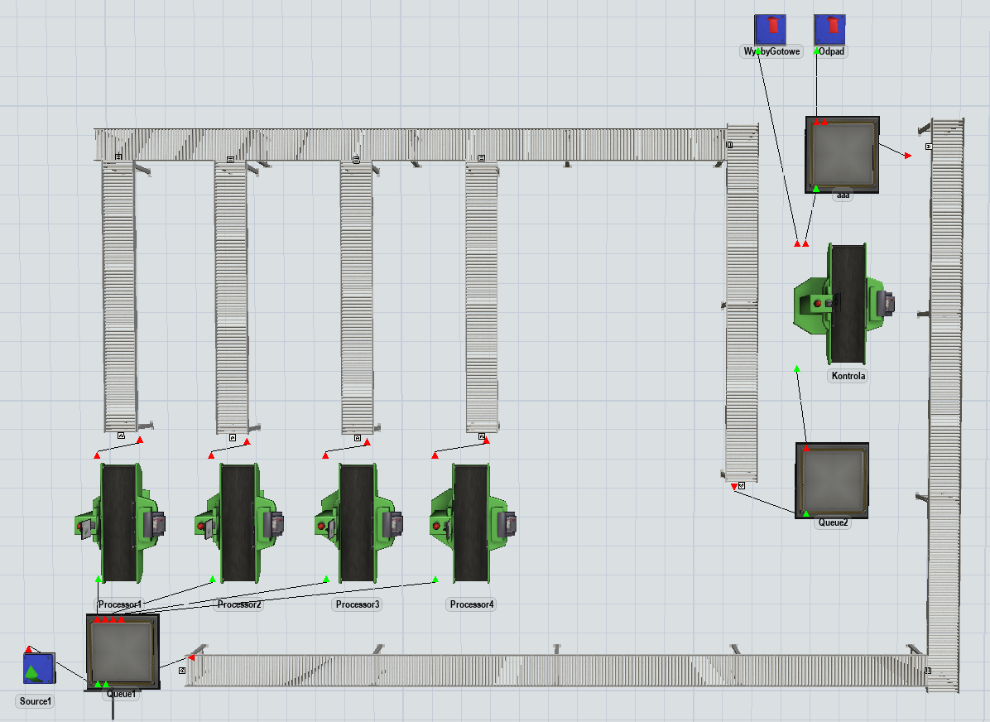
Fig. 1. Target structure of the model
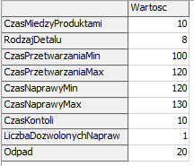
The input data is presented in the Data table in Figure 2.
Fig. 2 Input data

Object parameters and flow logic

Flow element
For the flow element in the Flowitem Bin, four labels must be added as shown in Figure 3:
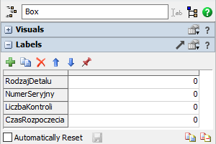
- DetailType – contains information about the product type.
- SerialNumber – a unique number for each item.
- NumberOfControls – number of quality tests for a given product.
- Start Time – information about the start time of processing
Fig. 3 Labels for the flow element

Source
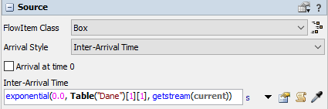
The time between subsequent products will be determined by referring to the appropriate cell in the Data table (Fig. 4).
Fig. 4 Source Settings
Marking flow elements with a SerialNumber label will be carried out in two steps. This is a solution suitable for a basic level of knowledge of the program. The first step is to add a label called Number to Source1 (Fig. 5). Each product generated by the source will automatically have its value incremented by 1. Then the current value of the Number label will be assigned to each element, leaving the source and in the form of a SerialNumber label.
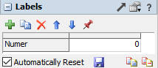
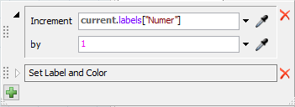
It belongs in the Triggers section, under On Creation → Data → Increment Value (Fig. 6). Next, you need to indicate the label whose value will be increased (Number).

Fig. 5 Label Number on Source1 Fig. 6 Increasing the value of the label Number on Source1.
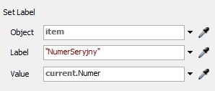
The second step is to add the entered value of the Number label to the SerialNumber label when exiting the source – OnExit → Data → Set Label. In the dialogue box (Fig. 7), select the appropriate label name, this time already placed on the product, and give it a value corresponding to the Number from the Source label.
Fig. 7. Assigning a value to the SerialNumber label
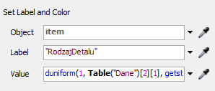
The final step will be to mark the product type generated by Source1 and assign it a colour. We will use the already known reference to the global table Data - On Creation → Data → Set Label and Colour (fig. 8).
Fig. 8. Element type and colour settings

Processing stations
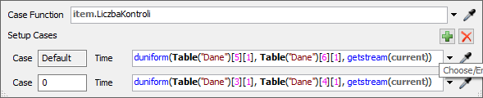
The processing time for each of the four machines will be set according to the values in the Data table. The processing time will depend on the number of checks. Processor → Process Time → Values by Case. The expression used to set the appropriate processing time is item.NumberOfChecks (Fig. 9). If its value is zero, the control time will be equal to a random number between 100 and 120 seconds, or between 120 and 130 seconds.
Fig. 9 Processing time settings depending on the number of checks
The next task, according to the assumptions, is to assign the appropriate task priority, i.e., to ensure that the elements for reprocessing enter the machines first. This means giving priority to elements with a higher Control Number label value. In the Machine Input tab, select Pull → Pull Best Item. In the next window, enter the settings as in Fig. 10.
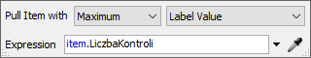

Fig. 10. Priority for items to be recycled

The StartTime label remains unset and will be set each time the element enters the processing station. OnEntry → Date should be selected on it → Set Label. The current model time should be set as the Value label using the Model. time command (Fig. 11).
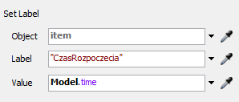

Fig. 11. Assigning the start time of processing

Quality control station
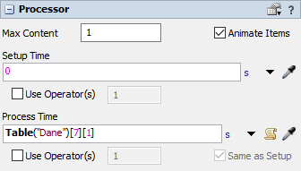
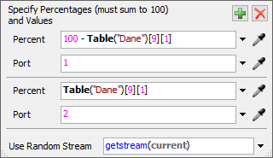
The quality control time is taken from the Data table (Fig. 12). In the Output tab, the flow logic is defined, accounting for 20% defective elements (Fig. 13).

Fig. 12 Quality control time Fig. 13 Quality control station output settings
Port 1 is intended for finished products, while Port 2 directs products for reprocessing to the Queue3 buffer (Fig. 14).
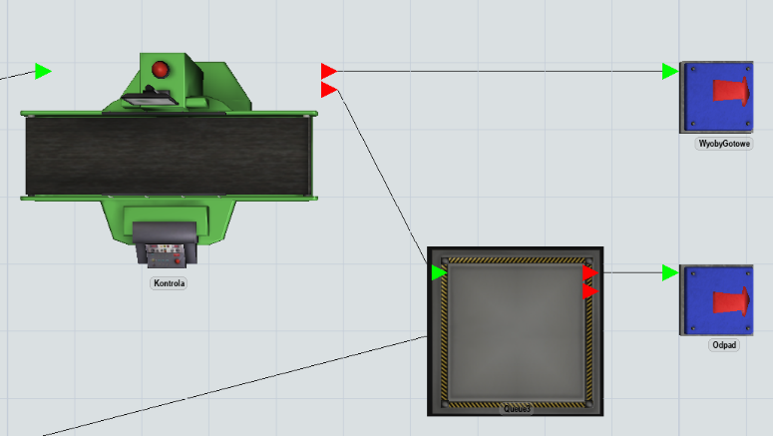

Fig. 14. Outgoing calls from the quality control station
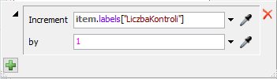
The last step is to add a trigger that sets the label with the number of checks: On Process Finish → Data → Increment Value (Fig. 15).
Fig. 15. Assigning a value to the ControlNumber label

Buffers
There are three buffers in the model:
- Queue1 – before processing stations. In the output section, enter the settings (Fig. 16) so that parts 1 to 4 are sent to the next machines, while any other parts that appear will be distributed randomly.
- Queue2 – remains at default settings.
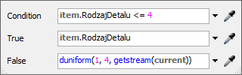
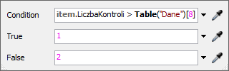
- Queue3 before the quality control station. In the Output section, enter the settings so that the parts with the number of inspections greater than the allowed number of repairs are removed from the system to the Waste output on the output port 1 (Fig. 17). The parts for which repairs are allowed go to the conveyor connected to the buffer via port 2.
Fig. 16 Output settings for Queue1 Fig. 17 Output settings for Queue3

Conveyor system
The model uses a simple conveyor system connecting individual elements. The detailed settings of the conveyors will be discussed in the next classes; for now, the goal of the task is to correctly arrange and connect the necessary elements.
After transferring to the StraightConveyor, you can define the flow direction indicated by the yellow arrow. Red crosses will also appear at the ends of the selected conveyor, allowing you to change its length and rotation angle (Fig. 18).
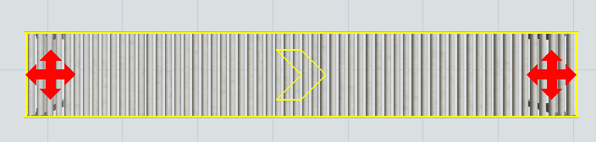
Fig. 18 Basic view of the conveyor
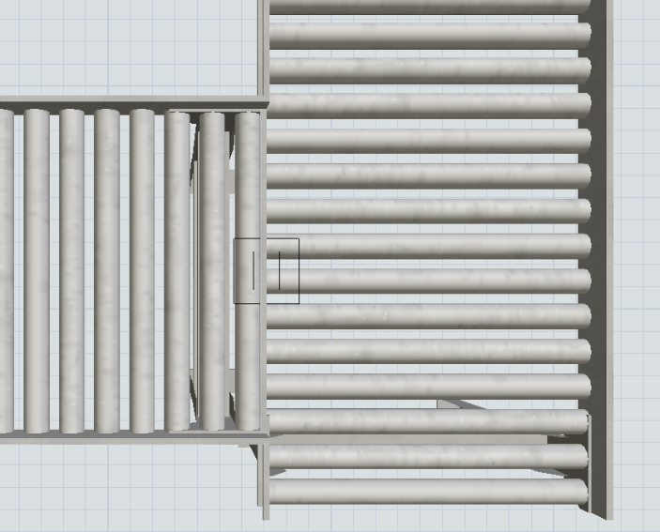
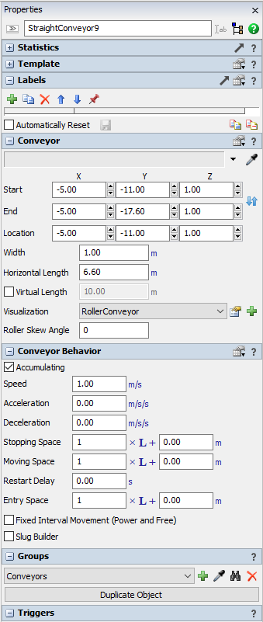
The basic parameters of the conveyor can be modified in its settings (Fig. 19). Objects of this type do not have a Ports section. Still, they are connected to other objects using regular directional connections "A". Conveyors are connected by moving them, while maintaining the same height of the connecting points. The connection symbol is shown in Fig. 20 as a black square.

Fig. 20. Conveyor connection symbol

Fig. 19 Conveyor settings

Report
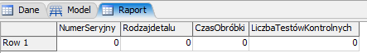
The simulation results will be analysed in the global Report table, with the headers shown in Figure 20.

Fig. 20 Report table settings
The table will be updated every time a machining operation is completed on each machine. You should also check On Reset → Delete All Rows to clear the table contents after each reset and restart.
The trigger on the processing stations is responsible for completing the table: Triggers → On Process Finish → Date → Add Row and Data to Global Table. It should be configured as shown in Figure 21.
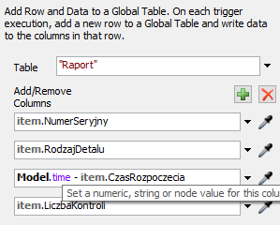
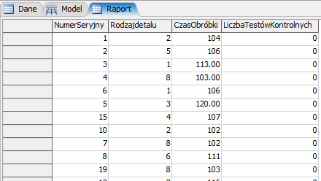
After running the simulation, subsequent entries will appear in the Report table (Fig. 22).
Fig. 21. Data recording trigger configuration Fig. 22. Data in the Report table
in the Report table

