 | 

Work Package 3: Theoretical and practical teaching materials development for transport in Cameroon and the Democratic Republic of Congo

T3.5 Logistic management
Supply management and logistics - Tutorial



MODELING OF LOGISTICS PROCESSES
ACTIVITY #7

Conveyors – additional functions

List of authors:
Gdansk University of Technology
Daniel Kaszubowski, Justyna Staszak-Winkler, Wojciech Kustra

Contents:

1 Objective and new skills 3
2 Basic types of conveyors 3
2.1 Straight Conveyor – Straight Conveyor 3
2.2 Curved conveyor Conveyor 6
2.3 Connecting conveyors 6
2.4 Engine – Engine 7
3 Flow control 8
3.1 Decision Point​ 8
3.1.1 Properties 8
3.1.2 Triggers 8
3.2 Service Station – Station 13
3.3 Photocell – Photo Eye 13
3.3.1 Properties 13
3.3.2 Triggers 14

Objective and new skills
The task aims to discuss detailed options related to the use of a conveyor system and flow control using service stations, decision points and photocells.
New skills
Adding and connecting different types of conveyors, transfer points
Controlling the operation of conveyors, configuring locations for flow elements – engine (Motor)
Using decision points to control the flow of elements and create zones
Principles of operation of a service station (Station)
Using the photocell capabilities (Photo Eye)

Basic types of conveyors

Straight Conveyor – Straight Conveyor
The basic type of conveyor is a straight conveyor, which was used in the previous task. Conveyor properties can be modified in the Conveyor sections and Conveyor Behaviour (Fig. 1).
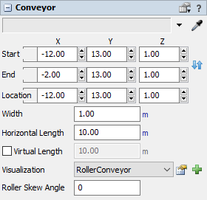
- Start/End/ Location – specifies the position of the end and beginning of the conveyor in the XYZ system. The opposing blue arrow symbol lets you change the flow direction. The Location values match those in Start.
- Width – width of the conveyor.
- Horizontal Length – conveyor length
- Virtual Length – the actual length of the conveyor, other than what is shown in the model. The value entered in this field will override the Horizontal Length.
Fig. 1 Basic conveyor settings
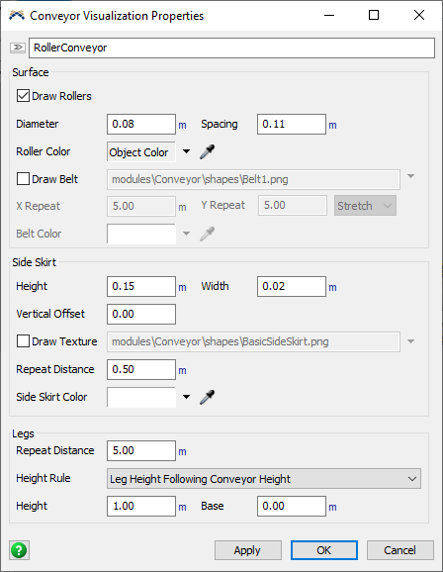
- Visualisation – changes the look of the conveyor: RollerConveyor – roller conveyor, BeltConveyor – belt conveyor, MassFlowConveyor – belt conveyor without mounted rollers. After selecting the conveyor type field on the right, its detailed parameters appear (Fig. 2). Pay attention to the Legs section, where you set the rules for visualising conveyor supports. The Leg Base Relative to Model option is most commonly used, causing the conveyor to snap to the model plane.

Fig. 2 RollerConveyor Settings
- Roller Skew Angle – ability to set the roller rotation angle to a given value (Fig. 3).
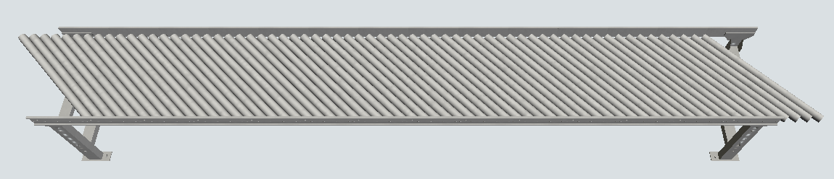
Fig. 3 Conveyor rollers set at a 45-degree angle
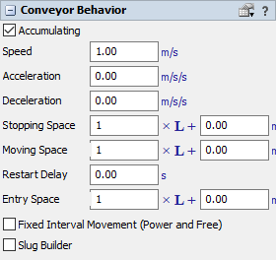
Further conveyor configuration options are available in the Conveyor section, Behaviour (fig. 4):
- Accumulating – the conveyor is treated as an accumulating conveyor, enabling the stopping of a single flow element without stopping the entire system.
- Speed – the speed of movement of flow elements on the conveyor.
- Acceleration/ Deceleration – conveyor acceleration and deceleration parameters.

Fig. 4 Conveyor Section Behaviour

- Stopping Space – specifies the space required to stop the flow element. The parameter is given by an equation, where L is the length of the flow element. An example notation 2 x L + 0.5m means that elements with a length of 1m after stopping will be 2.5m apart.
- Moving Space – space required during transport. The parameter is calculated in the same way as Stopping Space.
- Entry Space – required space for the flow element that enters the given conveyor. The parameter is calculated in the same way as the previous two.
- Fixed Interval Movement (Power and Free ) – ability to define fixed location lengths for flow elements ( Dog Interval parameter ).

Curved conveyor Conveyor
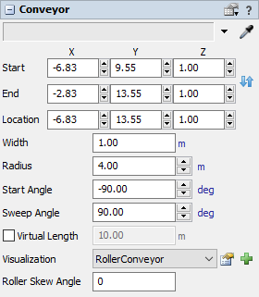
For curved conveyor options, Conveyor Behaviour is the same as for the straight conveyor. Additional functions appear in the Conveyor section (Fig. 5). Radius allows you to specify the radius of the arc defined by the conveyor, Start Angle specifies the value of the starting angle, and Sweep Angle specifies the angle of rotation. The length is not defined as Horizontal Length, but you can select the Virtual Length option.

Fig. 5 Curved conveyor settings

Connecting conveyors
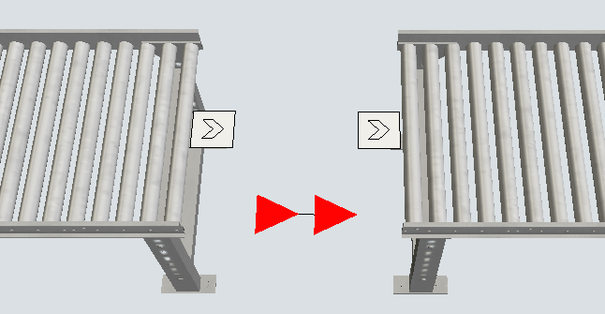
Conveyor belts can be connected using standard directional connections "A". Transfer points (white squares with an arrow) will then appear at the connection point - the outgoing Exit Transfer, the incoming Entry Transfer (Fig. 6). However, this is not a typical solution.
Fig. 6. Connecting conveyors with a directional connection
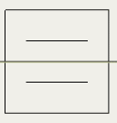
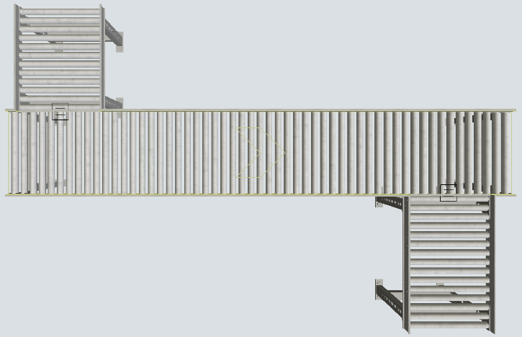
Transfers appear at the connection point, allowing flow between the conveyors.

Fig. 7 Connecting conveyors and transfer points
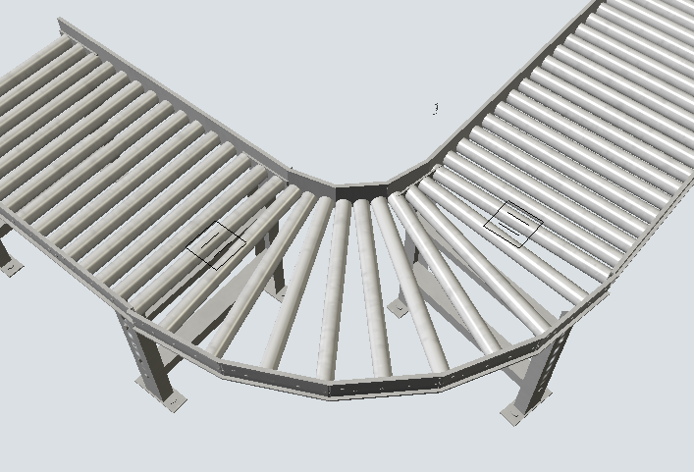
The last way to connect conveyors is to use the Join Conveyors option, available in the object library. It connects two straight conveyors with an arc. To do this, select this option and then select the conveyors to connect (Fig. 8).

Fig. 8 Connecting conveyors using Join Conveyors

Engine – Engine
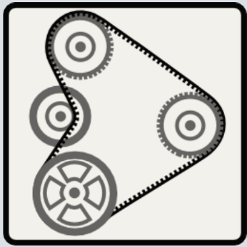
The engine is used to control the selected conveyor system, i.e. to start and stop it at selected moments (Fig. 9).

Fig. 9 Engine
The following engine operating parameters can be determined:
- Sync Power and Free Dog Position – When this setting is selected, Power and Free mode can be used on conveyors, which allows for defining fixed location lengths on conveyors for flow elements. The entire conveyor system will operate as one continuous chain. The start of the first location at the beginning of the first conveyor will be set at its beginning, while the other conveyors will be coordinated with it in this respect. For example, the first conveyor connected to the motor is 10.2 m long, and the single location is 1 m long. Therefore, the start of the first location will be set at the beginning of this conveyor (at a distance of 0 m from its beginning) and at a distance of 0.8 m from the beginning of the second conveyor.
- Adjust Dog Gap for Continuous Loop – When this option is checked, connected conveyors are treated as a closed loop. The engine will calculate the total loop length and adjust the location length so that the total loop length is divided equally by the location length. For example, if the loop is 100.2 m long and the location is 1 m long, the engine will change the latter to 1.002 m (100.2/100).

Flow control

Decision Point​

Properties
Decision points allow you to perform various actions on the flow elements on the conveyors. They are in the form of a blue diamond (Fig. 10), and the properties are set in the Decision Point section (Fig. 11). The point is correctly placed on the conveyor if its diagonals are visible, the symbol is empty, and its position must be corrected.
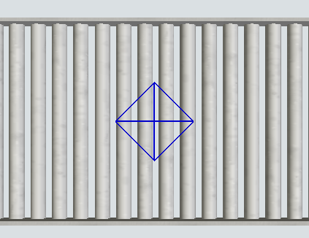
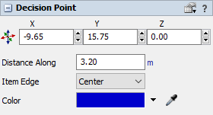
Fig. 10 Decision point on the conveyor Fig. 11 Decision point settings
- Distance Along – specifies the position of a point relative to the conveyor it is on.
- Item Edge – determines how a flow element triggers the logic of a decision point, i.e. what physical positioning of the element relative to the point triggers a given action:
  - Leading Edge – the front edge of the element,
  - Trailing Edge – the trailing edge of an element,
  - Centre – middle point.
- Colour – colour of the decision point.

Triggers
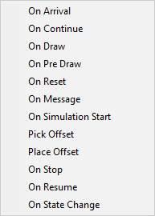
Like other objects, the decision point has Triggers that start various actions (Fig. 12). The most commonly used are On Arrival and On Continue. They trigger a set task when a flow element enters and leaves a decision point.

Fig. 12 Triggers for the decision point
Some of the available actions initiated by triggers overlap with those discussed earlier (Fig. 13), while those specific to the conveyor system are:
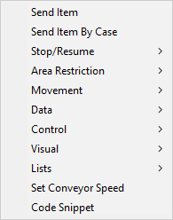
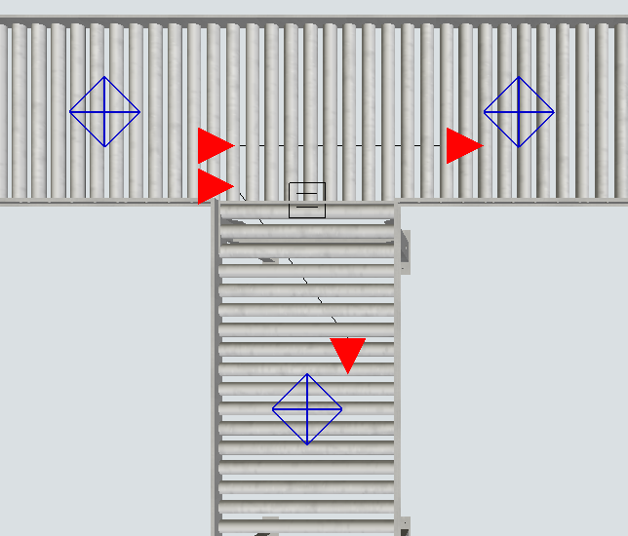
- Send Item – allows you to send a flow item along a specified path. Although decision points do not have Input/Output ports, they can be connected via directional connections to define the flow logic (Fig. 14).
Fig. 13 Actions for a decision point Fig. 14 Decision points - directional connections
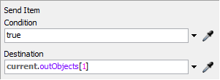
Configuring this option involves setting the Condition that must be met for the flow element to be sent further and specifying the destination (Destination) (Fig. 15).

Fig. 15 Send option Item.
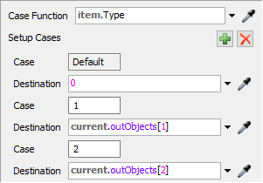
- Send Item by Case – allows you to send a flow element along a selected path depending on whether certain conditions are met (Fig. 16). The option works similarly to Send to Port → Port by Case for other model objects. The Case Function field contains an expression that will be a reference for selecting the destination.
Fig. 16 Send Item by Case
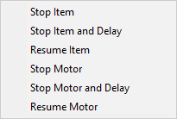
This can be, for example, a label defining the type of product that was used in previous tasks. Further possible cases are added. There is also a Default case available, intended for undefined variants. The value "0" means sending them to the first free destination (First Available).
- Stop/resume – stops or releases a previously stopped flow element or conveyor control motor. There are several options available (Fig. 17). They share a similar layout, including a condition to be met and an indication of the target element/object (Fig. 18).
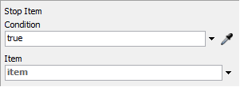
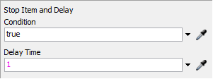
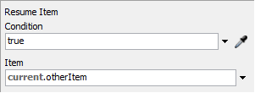
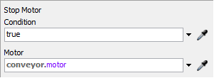
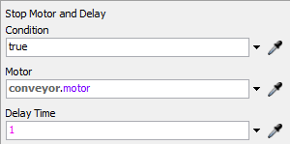
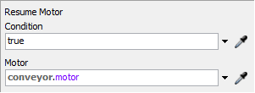
Fig. 17 Stop/Resume

Fig. 18. Details of actions in the Stop/Resume section
- Area Restriction – allows you to perform the following actions:
- Acquire Area – declaration of occupation of a designated area,
- Release Area – release of the designated area,
- Allocate Control Area
- Deallocate Control Area
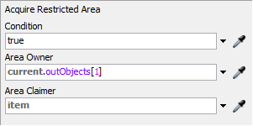
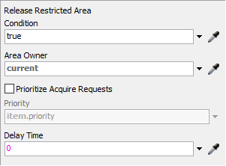
The zone is the area limited by decision points. In the Acquire option Area (Fig. 19), the Condition is entered, which must be met to occupy the zone. It is important to set the Area Owner correctly because each zone is defined by its start and end points, and it is necessary to indicate which of them is responsible for controlling the zone (the "zone owner"). Area Claimer, in turn, indicates the object that occupies the zone.
Fig. 19 Acquire option Area

Fig. 20 Release Area option
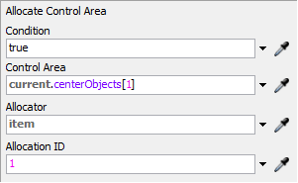
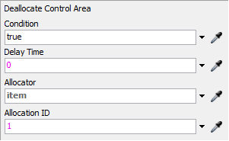
The release Area option has similar settings (Fig. 20). Additionally, you can set whether seizure reports should be sorted by priority (Prioritise Acquire Requests) and specify an expression to assign priorities. You can also pass the delay after which the element will be released from the zone.

The Allocate/Deallocate Control Area function pair allows the flow element to occupy or release a control area (Control Area) on the model plane, selected from the AGV library. This means that the flow of elements on the conveyor can be associated with the control of operator behaviour (e.g., people or forklifts).

Fig. 20 Allocate/Deallocate Control
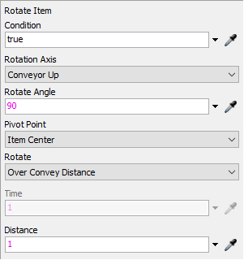
- Movement – allows rotation (Rotate Item) and/or turnover (Transale Item) of the flow element on the conveyor (Fig. 21).
- For Rotate Item is set:
  - Condition – condition to be met for the element to be rotated.
  - Roatation Axis – the plane of rotation; by default, it is the upper plane of the Conveyor Up; you can also select the left or right plane (Conveyor Left/Right).
Fig. 21 Rotate Item
  - Rotate Angle – rotation angle.
- Pivot Point axis of rotation on the flow plane; by default, this is the axis defined vertically between the centre points on the upper and lower planes of the flow element.
- Rotate – rotation method; after selecting Over Convey Distance, the rotation will be performed over a distance entered in the Distance field; For the Over Time option, the rotation time is set (Time field).
For Translate Item is set (Fig. 22):
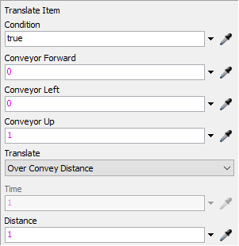
- Condition – the condition required for the flow element to be moved,
- Conveor Forward / Left/Up – shift distance in each plane,
- Translate – the method of moving; settings identical to the Move Item option.

Fig. 22 Translate Item
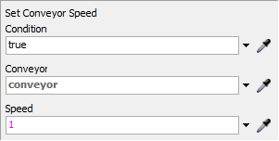
- Set Conveyor Speed – allows you to change the conveyor speed (Fig. 23).

Fig. 22 Set Conveyor Speed

Service Station – Station
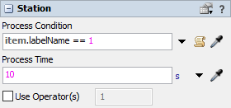
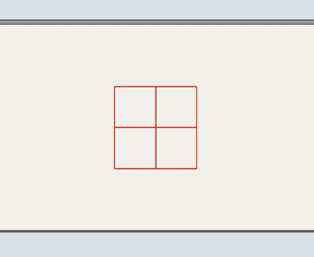
Station is a decision-point variant that allows processing elements on principles identical to those in standard Processor machines (Fig. 23). You can define the condition that must be met to start processing and the processing time. You can also assign operators to perform tasks.

Fig. 23 Service station and its parameters

Photocell – Photo Eye

Properties
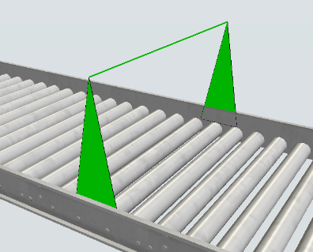
Photo Eye is a decision point that allows a specific action to be performed when a flow element intersects the laser beam (Fig. 24). The beam height is defined in the Height settings field. Elements lower than the ones entered in this field do not activate any action.
Fig. 24 Photo Eye
There are several photocell settings available (Fig.25):
- Block Time – the time for which the element is stopped after cutting the laser beam.
- Clear Time – the time it takes to release the photocell.
- Offset Angle – value of the angle by which the laser beam is rotated on the photocell.
- Require Gap to Clear – a flow element can only be released when a gap appears between successive elements.

Triggers
The photocell is equipped with an extensive set of Triggers. It can be in four states: blocked, released, blocking and releasing. The triggers can be activated in the blocked or released state. Four of them will be used relatively often:
- On Cover – enables the execution of a given action whenever a flow element intersects the photocell beam.
- On Block – triggers an action when the photocell is blocked by a flow element for the time set by Block Time.
- On Uncover – allows an action to be performed each time a flow element leaves the space next to the photocell.
- On Clear – allows the action to be performed when the photocell is released, i.e. the transmission of the flow element that blocked it is resumed, and at the same time, the time specified in Clear has elapsed.

